Project Design Phase-II Technology Stack (Architecture & Stack)

Date | 15th February 2026
Team ID | LTVIP2026TMIDS80000
Project Name | Project - Online Payments Fraud Detection Using ML
Maximum Marks | 4 Marks

Technical Architecture:
The Deliverable shall include the architectural diagram as below and the information as per the table1 & table 2

Guidelines:
- Include all the processes (As an application logic / Technology Block)
- Provide infrastructural demarcation (Local / Cloud)
- Indicate external interfaces (third party API’s etc.)
- Indicate Data Storage components / services
- Indicate interface to machine learning models (if applicable)

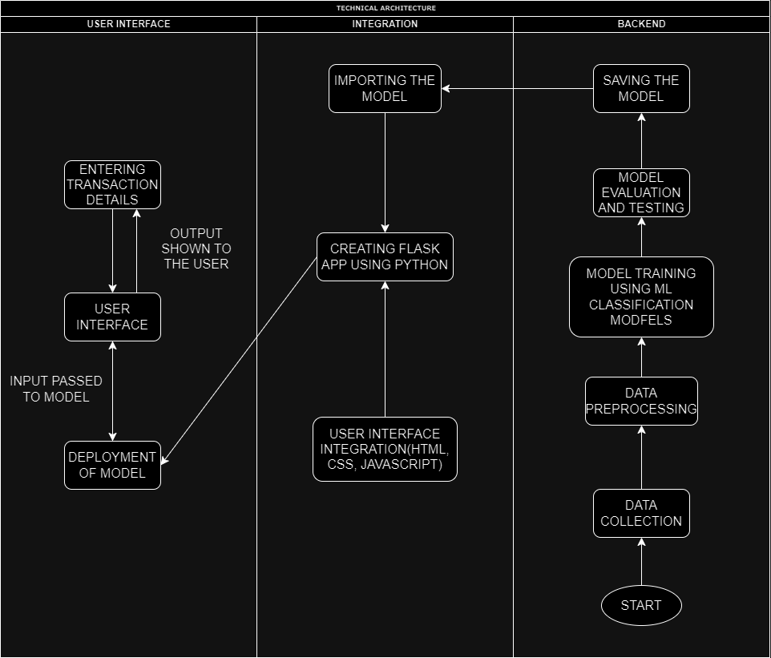

Table-1 : Components & Technologies:

S.No | Component | Description | Technology
1. | User Interface | How user interacts with application e.g. Web UI, Mobile App, Chatbot etc. | HTML, CSS, JavaScript
2. | Data Collection | Gathering the Transaction details | Kaggle
3. | Data Preprocessing | Feature Scaling, Normalization, data splitting, Data Visualization,etc. | Seaborn, Matplotlib, Scikit-learn, Numpy, Pandas
4. | Application Logic | Core Application Logic | Python (Flask)
5. | Database | Storing Transaction Data | Relational: PostgreSQL or NoSQL: MongoDB
6. | File Storage | Storing and Analyzing Data | Amazon S3, Google Cloud Storage
7. | Deployment | Creating API or application for predicting the decisions | Flask API
7. | Machine Learning Model | Fraud Detection Models | Decision Tree, Random Forest Classifier, SVM, XGBoost, Extra Tree Classifier
8. | Evaluation | Model Evaluation on validation and testing model using dataset | Accuracy Score, Confusion Matrix, Classification Report
9. | Infrastructure | Application Deployment on Cloud | Local: On-Premises Servers or Cloud: AWS, Azure, Google Cloud and Scaling Kubernetes, Docker

Table-2: Application Characteristics:

S.No | Characteristics | Description | Technology
1. | Open-Source Frameworks | Utilizing open-source frameworks and tools | Python Flask, Bootstrap
2. | Scalable Architecture | Embracing a scalable microservices | Microservices architecture using Docker and Kubernetes, Load balancing using Nginx
3. | Availability | Ensuring high availability through redundancy | Load balancers for even traffic distribution, redundant servers for failover, global server redundancy for uninterrupted service
4. | Performance | Optimizing performance through caching and CDN integration | Caching with Redis for rapid data retrieval, Content Delivery Networks (CDNs) for faster content delivery, Performance monitoring and optimization  for handling a specified number of requests per second

